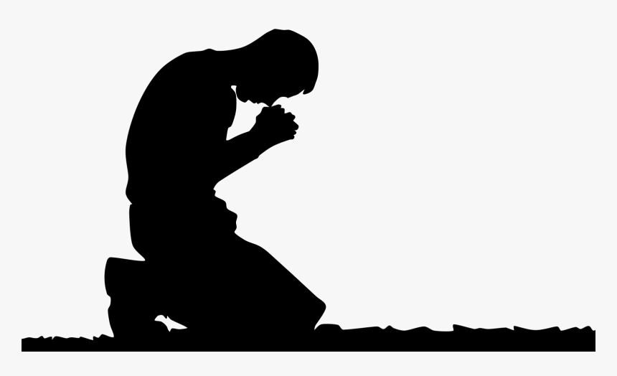
The Prayer
Jesus Gave Us
Pastor Toby • 9/17/2023
Learning How to Forgive
Ephesians 4:32, Colossians 3:13
Forgiveness is NOT…
- …a _________ of ________-_________. (Luke 23:34, Acts 7:60, Colossians 1:14)
- …_______________ what happened. (Jeremiah 31:34, Isaiah 43:25)
- …a ______________ of __________________.
Forgiveness IS…
- …___________ to __________ the debtor from the obligation to ______ me for the evil they’ve done.

The Elements of Forgiveness:
- Reject any plans to “_________ the ________.” (Romans 12:19a, Ephesians 4:31-32)
- Accept __________ payment for the debtor’s sin. (1 John 2:2)
- ________ the debtor from the obligation to repay. (Matthew 18:23-33)
- Defer ___________ to the _________. (Romans 12:19, 1 Peter 2:23)
- Do _________ to your debtor. (Matthew 5:44-47, Luke 6:35-36, Romans 12:20)
- Open yourself to the _______ of _______________ (if certain conditions are met). (John 3:16)

