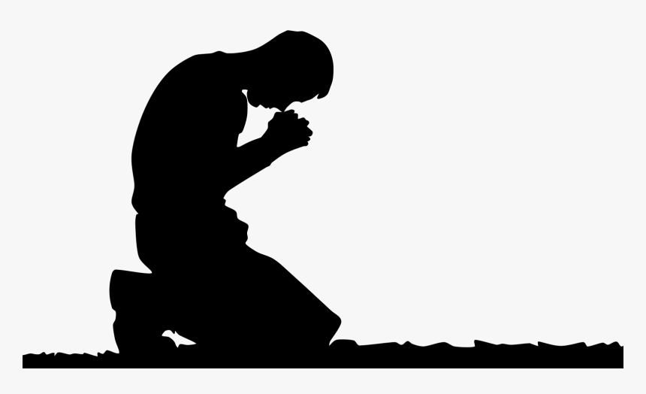
The Prayer
Jesus Gave Us
Pastor Toby • 9/10/2023
The “Fine Print” of Forgiveness
Matthew 6:12, 14-15
How God’s Forgiveness Works:
- Anyone who _______ on the name of the Lord will immediately receive the _______ and ___________ of being “forgiven.” (Romans 10:13)
- This new _______ does not immediately translate into the holy __________ and _____________ with God that we want and need.
- As we ___________ our sins to God each day and begin to _______ Him, we bring the blessings of our “Forgiven” ________ into our _____________. (1 John 1:9)
  - __________ over sin.
  - ____________ with God.

The “Fine Print”:
- Only two things can disrupt Your daily experience of the blessings of forgiveness:
  - An unwillingness to ________ with your sin. (1 John 1:9, 1 Peter 3:7, Psalm 66:18)
  - An unwillingness to _________ others. (Matthew 6:14-15, Mark 11:24-25, Luke 6:37)
Why is this such a big deal?
- It proves you don’t see _____________ properly.
- It proves you don’t see _______ properly.
- It proves you don’t understand how _____________ works.

