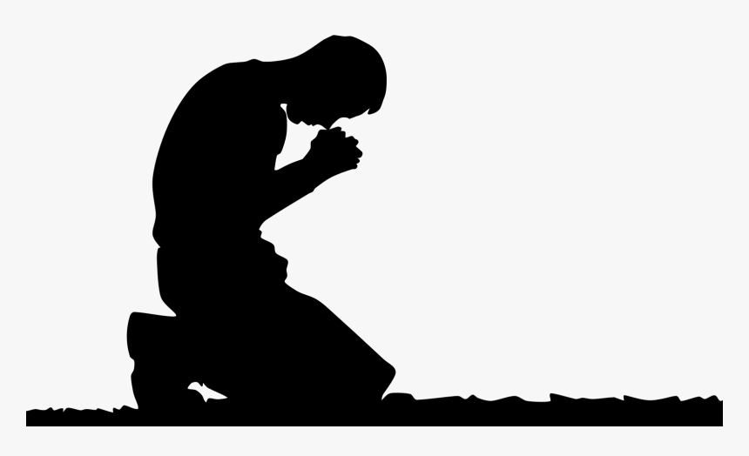
The Prayer
Jesus Gave Us
Pastor Toby • 8/27/2023
The Forgiveness(es) We Need
Matthew 6:12
How the “Good News” Works:
- All who call on the Lord receive _________. (Romans 1:16, Ephesians 1:13-14, 2 Timothy 3:15, Hebrews 5:9)
- ___________ includes ________________. (Acts 10:43, 26:18, Ephesians 1:7, Colossians 1:14)
- To be forgiven is to be ______________.
2 kinds of “release”:
  - ______________ release from…
    - Eternal _____________ for our sin. (Colossians 2:13-14, Romans 8:1, Hebrews 10:11-18, 1 John 2:2)
    - ________________________ against sin. (Romans 6:6-7, Philippians 2:12-13)
    - This release is dependent only on our willingness to ______ for it!
  - ______________ release from…
    - …the _________ of sin. (Romans 6:12-14, Phil. 2:12-13)
    - …the _________ from God created by sin. (1 Jn. 1:5-9)
    - This release is dependent on our willingness to…
      - ___________ our sin. (1 John 1:9)
      - ____________ our sin. (Revelation 3:19)
      - _________ Jesus enough to ______ Him. (1 John 2:3-6)

