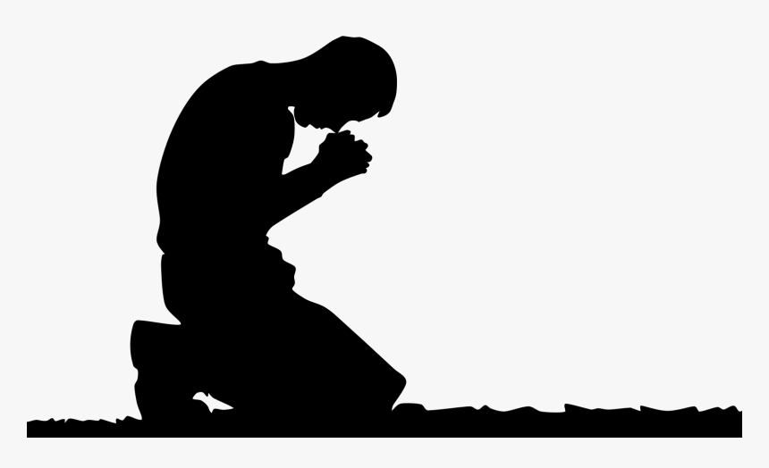
The Prayer
Jesus Gave Us
Pastor Toby • 8/20/2023
Who Needs Forgiveness?
Matthew 6:12
Our “Model” Prayer Reminds Us…
- We are ___________.
  - We owe God a _______. (Matthew 6:12, Ecclesiastes 7:20, 2 Chronicles 6:36, 1 John 1:8, Romans 3:23a)
  - We have denied God ________. (Romans 1:21-25)
  - We can’t measure up to God’s ______________. (Romans 3:23b)
  - We are ____-___________ and ____-_________. (Romans 3:9-12)
- We are in need of _______________.
  - There is no _____________ plan. (Isaiah 64:6, Galatians 2:16, Titus 3:5)
  - We have earned ________. (Romans 6:23)
  - We are on a collision course with God’s __________. (Ephesians 2:1-3)
- God is _______ to forgive all who ____. (Acts 10:43, Romans 10:9-13, 1 Jn 1:9, Colossians 2:13-14)

Your Assignment for this week:
- The next time you pray, begin with the Lord’s Prayer.
- When you get to the “Forgive us our sins” part…
  - What sins have tripped you up since your last prayer time?
______________________________________________________
______________________________________________________
______________________________________________________
______________________________________________________
______________________________________________________
______________________________________________________
______________________________________________________
______________________________________________________
  - Admit your guilt to God and ask for His forgiveness for those specific “debts” you’ve incurred this week.
  - Reflect on God’s eagerness to forgive you and take a few moments to be thankful. What could you thank God for (specifically as it relates to your sinfulness and need for forgiveness)?
______________________________________________________
______________________________________________________
______________________________________________________
______________________________________________________
- Then continue to pray as you had already intended.

