GOD In His Own Words
Pastor Toby Locke • Week 3 • 10/15/2023
Bad Religion
Isaiah 1:1-20
The Bad News:
- You have ________ our ______________! (vs. 2-10)
The Objection:
- But we do lots of ____________ things! (vs. 11-15)
The Diagnosis: (vs. 11-15)
- You’re “_____-________” Me.
- You’re _________ Me.
- You’ve __________ Me. (1:3-4, 29:13)
The Prescription:
- Stop trying to “________” Me. (vs. 12-13)
- ________ with Me! (vs. 18)
- Change your ________. (Isaiah 1:19, Matthew 22:36-38)
- Integrate your _______ with your ___________ life.

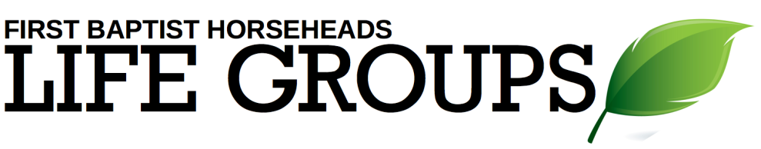
Debrief Plan: 10/15/2023
Icebreakers:
- Imagine that you could instantly teleport yourself anywhere. Where would you go?
- What is a religion besides Christianity that you would be curious to learn more about? Why did you pick that one?
Sermon Summary: God is deeply offended by us when we think that we can bribe Him into ignoring our blatantly sinful behavior by regularly engaging in prescribed religious practices at the same time. Such “two-timing” behavior will lead to God’s discipline and even more distance between us and God.
Discussion Questions:
- God’s very first words to Israel in Isaiah’s prophecy are words of rebuke. Why does it seem that God is always determined to give us the bad news first? Is this a good thing or a bad thing?
- Read Isaiah 1:4-10. Do you think Israel saw themselves the way that God saw them? Why do we find it so easy to deceive ourselves?
- Read Isaiah 1:11-15. Why isn’t God satisfied with proper religious ceremony?
- Why are we so often satisfied with offering God mere religious ceremony?
- What does it tell us about the heart of God that He is so upset and hurt by our bad behavior?
- How can we tell that we are trying to “hustle” God by performing religious activities?
- Share some ideas with one another about how to go about “reconnecting” with God after a long time of being/feeling distant from Him.
- What areas of everyday life are the hardest to integrate with a life of faith?

