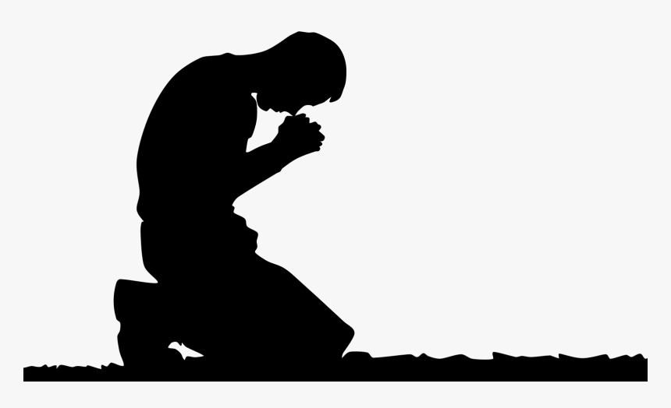
The Prayer
Jesus Gave Us
Pastor Toby • 9/24/2023
Take Evil Seriously
Matthew 6:13
Warnings to Heed:
- We have an ________. (1 Jn. 5:19, 1 Pet. 5:8, Eph. 6:11-12)
- This ________ sets ________ for us. (Mt. 4:1-3, 1 Thess. 3:5, 1 Tim. 3:7, 2 Tim. 2:26)
- God allows them to _______ us. (Mt. 4:1, Jms. 1:2-4, 1 Cor. 10:13)
- We are _______ to take evil ___________. (1 Pet. 5:8, Mt. 26:41, Gal. 6:1)
How Do We Take Evil Seriously?
- Pray to be spared ____________ _______. (Mt. 6:13a)
  - Traps I create by my __________ ________. (Jms. 1:13-16, Rom. 13:14)
  - Traps I refuse to ________ in my ________. (Mt. 4:7)
- Pray to conquer _____________ _______. (Mt. 6:13b)
  - Tests that _______ brings my way. (Jn. 16:33, 1 Pet. 1:6-7)
  - Tests that I _______ to grow my ________. (Jms. 1:2-4)

Debrief Plan: 9/24/2023
Icebreakers:
- What was the most fun activity you engaged in over the summer since your life group last met?
- Do you own something that is quite old and has special meaning to you? Share what it is with your group!
Sermon Summary: Followers of Christ cannot afford to be naïve – we have an Enemy setting traps for us every day, and God will allow us to face many of them to test us and grow our faith. We take this threat seriously when we pray that God would help us avoid unnecessary traps and then pray that God would enable us to conquer those tests He deems are necessary to our spiritual growth.
Discussion Questions:
- Are we more likely to underestimate our Enemy’s attacks or overestimate them? Which is more dangerous?
- Read 1 Thessalonians 3:15, 1 Timothy 3:7, 6:9, and 2 Timothy 2:26. What kinds of “traps” do you see in these passages? Which are we most vulnerable to in 2023?
- Read 1 Peter 5:8, Matthew 26:41, and Galatians 6:1. What does “watching” for temptations look like?
- How can you tell the difference between an “unnecessary” trap we should pray to avoid and a “necessary” test we must pray for the strength to endure?
- Read Ephesians 6:11-18. What hints does this passage give of how God intends for us to “resist” the devil?
- Read James 1:2-4. Have you ever experienced a trial that could have destroyed your faith but instead strengthened it? Why do you think it ended up helping you instead of hurting you?

