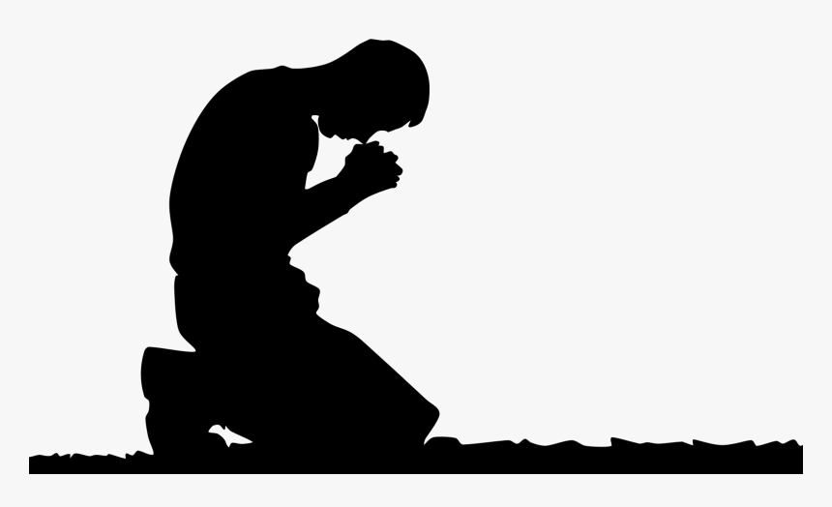
The Prayer
Jesus Gave Us
Pastor Toby • 7/9/2023
What’s the Big Deal?
Luke 11:1-13
Objections to Prayer:
- It’s too ___________.
- It’s too _______.
- I never know if I’ve done __________.
- What’s the _______? God already _______ it all!
- It doesn’t make a ___________.
So, Why Should We Pray?
- _________ needed it. (Luke 11:1)
- Jesus thinks ______ need it. (Luke 11:2-13)
  - It teaches us to see _______ properly. (Luke 11:2a)
  - It reveals God’s ________ of ________. (Luke 11:2b)
  - It reminds us how much we ________ Him. (Luke 11:3-4)
  - It proves that God is _________ with us. (Luke 11:5-8, 11-13)
  - It coaxes us to ___________ with God. (Luke 11:9-10)

