The First and Final Word
Pastor Toby • Week 11 • 5/22/2022
Loving Our Neighbors
Matthew 22:39
Why Should I Love My Neighbor, Again?
- To show Jesus that I love HIM.
- To prove I __________ to God.
- To ______ sin of its ____________.
- To show the world Jesus is _________.
But What If I Don’t WANT To Love?
- ______________ who you are.
- Beg God for His ________.
- ____ loving _______ until you ______ loving ________.
Conclusion: We can’t love our neighbors unless God shows up in a miraculous way. Will you cry out to Him for help today?

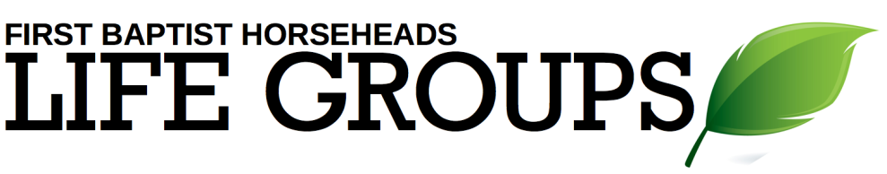
Debrief Plan: 5/22/2022
Icebreakers:
- Important patriotic holidays like Memorial Day and July 4th are coming up soon. Who is a figure from American history that you admire and why?
- What is your favorite summer “picnic” food and why?
Sermon Summary: Learning to love our neighbors as ourselves is near to the core of what it means to be a follower of Jesus. While there are many good reasons to choose to love, in the end we need God’s help if we are ever going to love our neighbors as He loves us.
Discussion Questions:
We’ve talked about why we should love, and what we should do if we don’t want to love, but let’s take some time and talk about what loving our neighbors might look like in real life…
Read John 13:34-35, 15:12.
- Jesus told his disciples that they needed to love each other in a particular way – what way was that? How is that form of love different (or more complete) than simply saying, “love one another”?
Read John 15:13, 1 John 3:16-18.
- How do these two passages add to our understanding of what love “looks like”?
Read Romans 12:9-10.
- Have you ever seen a love that is NOT “genuine”? How can we tell the difference between “fake” love and “genuine” love?
- How is “brotherly affection” different from the kind of love that we’ve been talking about? Is there overlap or are they completely different things? Is it easy for these two kinds of love to co-exist?
Read Romans 13:10.
- What does it mean to “do no wrong” to your neighbor? Why is this an important piece to the “love” puzzle?

